


Report CTF

Basic Pentesting Lab-2 Penetration Test Report

Date: 19/12/2025

1 Table Of Contents

- Document Revision History………………………………………………………….........................................2
- Executive Summary....................................................................................................................................3
- Scope..........................................................................................................................................................4
- Risk Categories...........................................................................................................................................5
- Pentest Methodology..................................................................................................................................6
- Visual Summary..........................................................................................................................................7
- Findings Summary......................................................................................................................................8

1 Document Revision History

Name | Date | Version | Contact Details
Sneha Shende | 19/12/2025 | 0.1 | Email: shendesneha64@gmail.com  Mob No: +91

u e
2 Executive Summary
An analysis of a black box penetration test conducted on the Metasploitable “CTF Machine” is presented in this document. Based on a thorough security assessment performed by Internal Security Team in july of 2025.
This assessment was conducted On-Premises by the Security team. An assessment was conducted on the 25th of july to 31th of july 2025. As a comprehensive strategy for this assessment, Security Team concreted the black box penetration testing methodology and technique. To facilitate this, Company provided a walkthrough of the application and provided access to the test environment with valid different privilege accounts.
Testing was carried out by identifying vulnerabilities with the intent of accessing critical information. The objective of performing this activity was to assess the security risks associated with the developed applications and identify vulnerabilities that cybercriminals could leverage to compromise the application. The report summarizes the security findings related to the Company applications and network.

This assessment aimed to:
Analyze the application for technical vulnerabilities that an attacker may exploit to compromise the CTF Machine.
Provide recommendations for risk mitigation that may arise on successful exploitation of these vulnerabilities.

3 Scope

Scope

The section defines the scope and boundaries of the project.

Constraints and Limitations

The assessments, and the result(s) / finding(s) made are highly subjective to target system(s) and service(s) visibility and availability at that given point of time.

Target Scope

Identify weaknesses that might be exploited by adversaries who have authorized or unauthorized access to Company Technical Skill Test and underlying infrastructure:
Test Perform On Hacksudo Thor CTF Environment Without Credential as Black Box Testing.
Following Machine was in the scope of the penetration test.

Machine and Environment Details

Sr . No CTF Name Url:
1 | Basic Pentesting - 2 (vulhub) | Machine Url: https://www.vulnhub.com/?q=basic+pentesting+2  Machine IP ( 192.168.56.101)

Contact Details

Names Contact Details
Sneha Shende (Penetration Tester) | Mail:shendesneha64@gmail.com

4 Risk Categories

Risk Categories & Rationales
Pentest use a simple risk categorisation of each vulnerability to focus the triage process at the risks which truly matter. The Common Vulnerability Scoring System (CVSS) is an industry standard formula. It generates a risk score between 0.0 and 10.0.
The table below explains the risk categories and demonstrates rule-of-thumb equivalency with CVSS scores:

Risk Category | CVSS Score | Rationales
Critical | 8.1 – 10.0 | Poses a severe risk which is easy to exploit. Begin the process of remediating immediately after the issue has been presented.
High | 6.1 – 8.0 | Poses a significant risk and can be exploited. Address these as soon as possible after any critical risks have been remediated.
Medium | 4.1 – 6.0 | Poses an important risk but may be difficult to exploit. Pentest recommends remedial work within 3 months of discovery.
Low | 2.1 – 4.0 | Poses a minor risk or may be exceedingly difficult to exploit. Address these over the long-term during testing cycles
Informational | 0.0 – 2.0 | Loss of sensitive information, or a discussion point. These are not directly exploitable but may aid an attacker. Remediate these to create a true defence-in-depth security posture,
CVSS is not applicable to all risks. For example, it is incapable of capturing the risk of a “flat network design”. Experience has told us that this is a “high” risk in most cases.
For this reason, the reader may find vulnerabilities which have no CVSS rating in our reports.
We endeavour to provide the reason for omitting the risk score when that is the case, and to provide CVSS by default in all applicable cases.

5 Pentest Methodology

Methodology

The penetration testing methodology is typically based on the NIST security methodology. The focus shifts from traditional application security, where the primary threat is from multiple sources over the Internet. The key difference is in the client-side security, file system, hardware, and network security. Traditionally for Thick Client Applications, an end user is in control of the device. Security Team used the NIST & MITRE Attack Framework testing guide for conducting penetration test of the systems and applications. The testing was done to simulate as closely as possible the viewpoint of completely external attacker, the steps involved are

1] Setup
2] Discovery
3] Enumeration
4] Detection
5] Exploitation
6] Post-Exploitation
7] Reporting

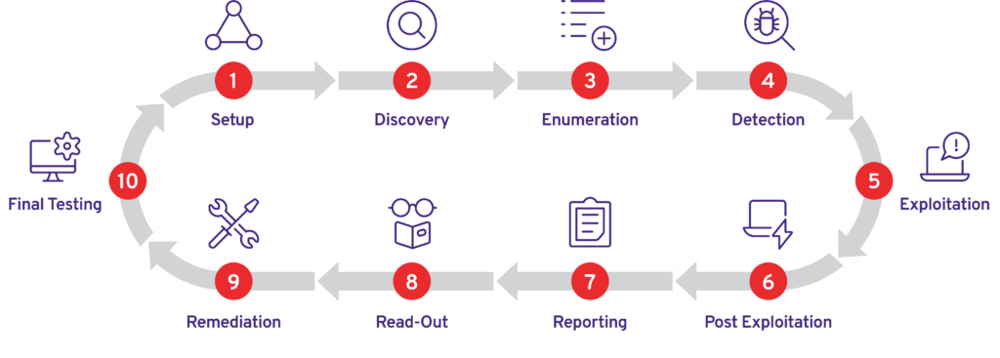

Visual Summary

Graphical representation of Identified Vulnerabilities to Severity Risk rating

Sr. No. Severity Level Frequency
1 | Critical | 2
2 | High | 1
3 | Medium | 1
4 | Low | 0

Table: Representing Severity Level

Findings Summary

# | Observed Vulnerability | Risk Rating | Status | Comments
1. | Exposure of Sensitive Development Files via HTTP | Critical | Not Fixed | --
2. | Weak Authentication and User Enumeration(SSH port 22) | Critical | Not Fixed | --
3. | Insecure SSH Private Key Storage | High | Not Fixed | --
4. | Unrestricted SMB Enumeration | Medium | Not Fixed | --

Below screenshot shows the ip address of Basic Pentesting lab 2 machine and its open ports found through nmap

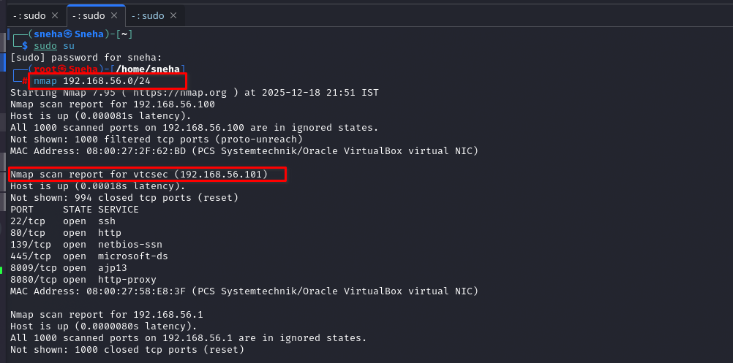

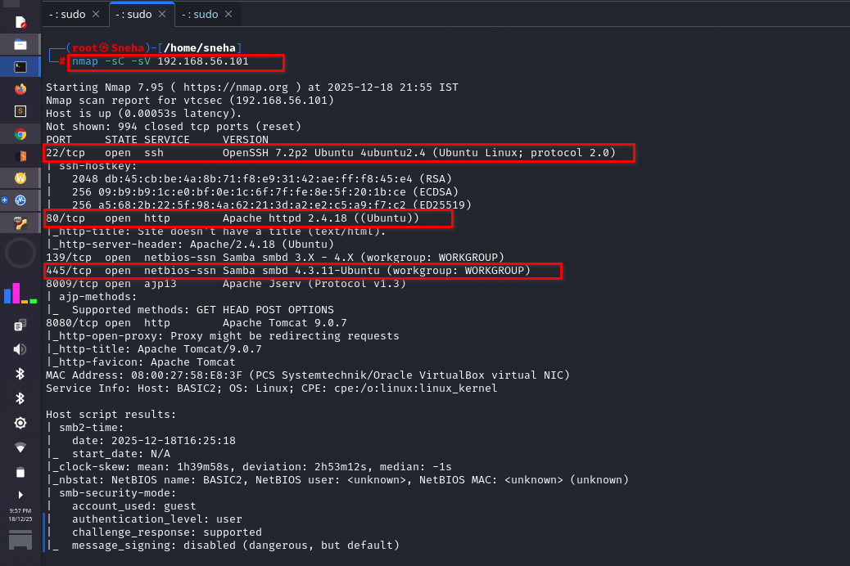

Exposure of Sensitive Development Files via HTTP

Vulnerability | Exposure of Sensitive Development Files via HTTP
Description | The web service running on port 80 exposed a /development/ directory without authentication. This directory contained internal development files that disclosed valid system usernames and password-related hints. Such information should not be publicly accessible on a production server.
Risk/Impact | Disclosure of internal information significantly reduces the effort required to compromise the system. Attackers can identify valid users and perform targeted attacks, which directly leads to unauthorized system access...
CVSS Score | 9.1 Critical
Path: | 192.168.56.101
Remidiation / Solution | Mitigation  - Remove sensitive files from web-accessible locations  - Disable directory listing  - Apply access controls to development resources
Refrence Url: | https://owasp.org/www-project-top-ten/2017/A3_2017- Sensitive_Data_Exposure

Below Screenshots shows the directory file which is open due to Apache httpd 2.4.18 which is on port 80

.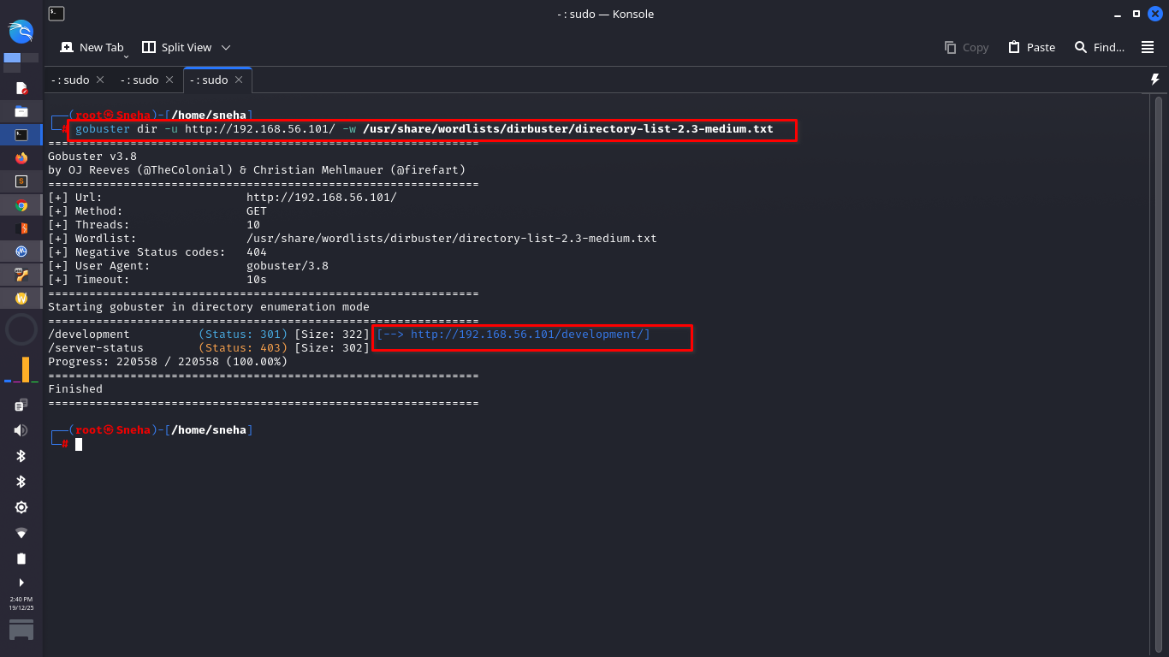

Weak Authentication and User Enumeration(SSH port 22)

Vulnerability | Weak Authentication and User Enumeration(SSH port 22)
Description | The SSH service running on port 22 suffered from multiple authentication weaknesses. The service allowed username enumeration through timing discrepancies in authentication responses, enabling attackers to confirm valid user accounts. In addition, weak passwords and weak passphrases protecting SSH credentials were in use, allowing successful credential cracking and unauthorized SSH access.
Risk/Impact | These combined weaknesses allow attackers to reliably identify valid usernames and compromise accounts using targeted password attacks. Once SSH access is gained, attackers can move laterally and escalate privileges, ultimately leading to full system compromise.
CVSS Score | 8.8 Critical
Path: | 192.168.56.101
Remidiation / Solution | Mitigation  - Disable password-based SSH authentication  - Enforce strong password and passphrase policies  - Implement rate limiting and monitoring on SSH  - Update OpenSSH to a hardened version
Refrence Url: | https://owasp.org/www-project-top-ten/2017/A2_2017- Broken_Authentication

Below screenshot shows the outdated version of openSSH 7.2p2 on port 22

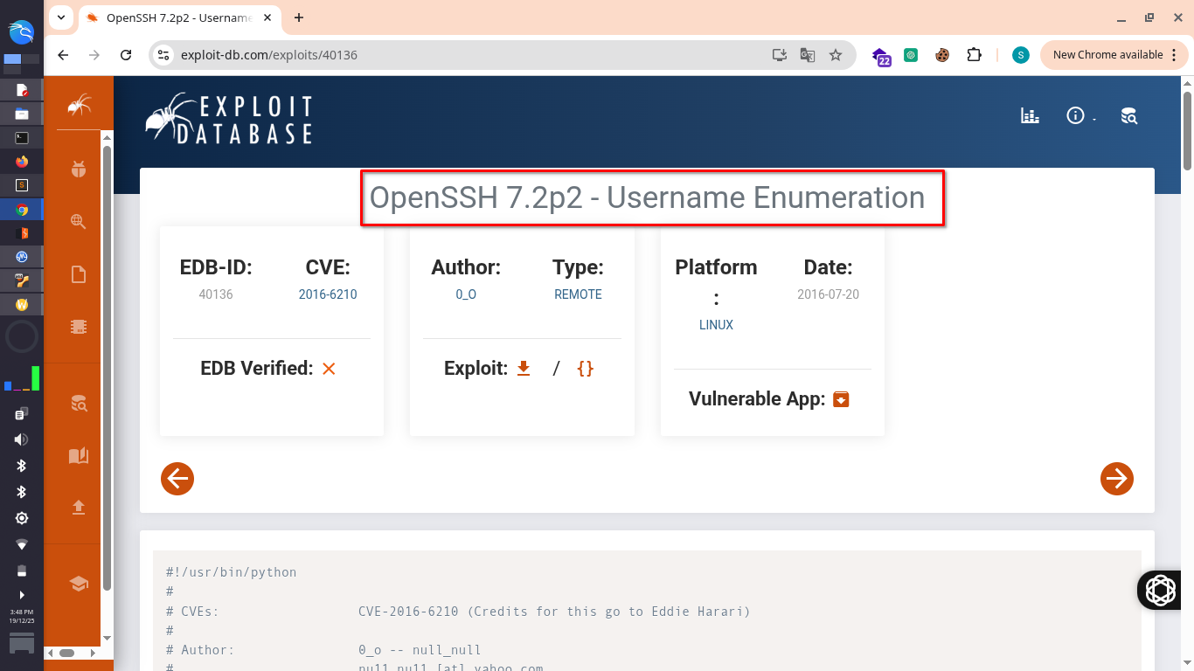

Below Screenshots shows that attacker found login id and password with the help of hydra command.

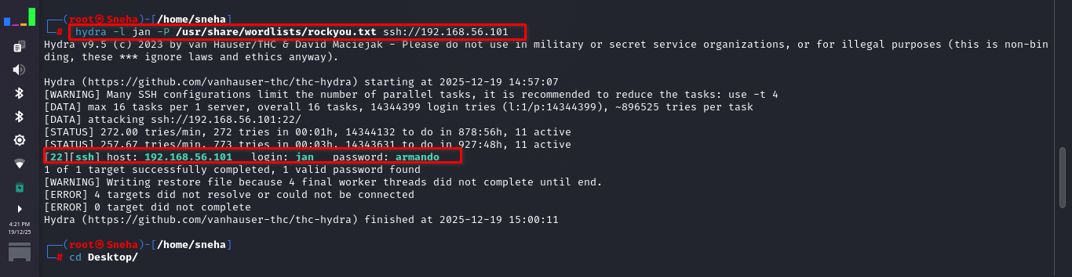

Below Screenshots shows that attacker found password and successfully entered in the account of jan .

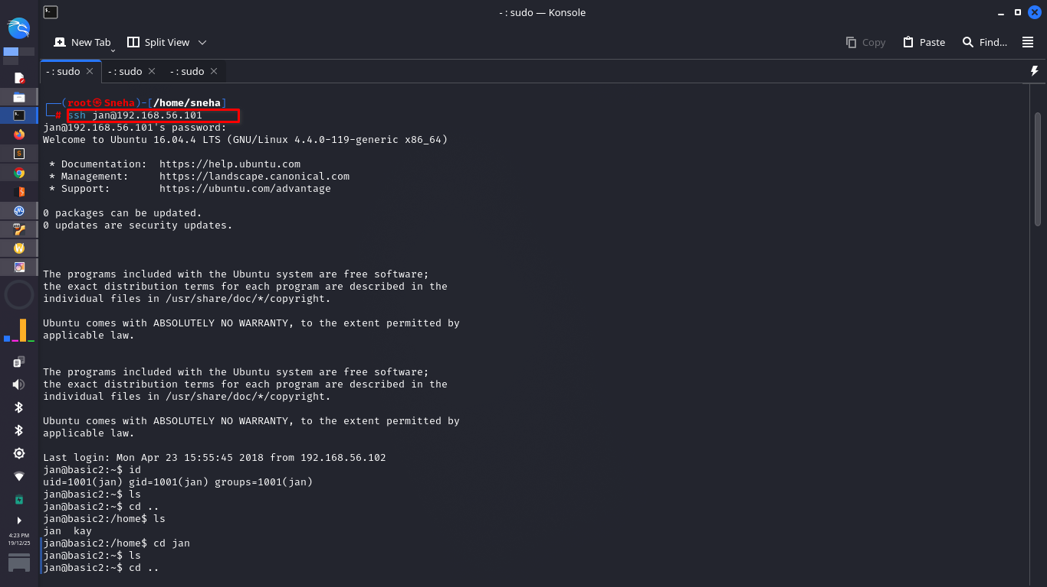

Below Screenshots shows that attacker found the information of kay and its password and passphrases.

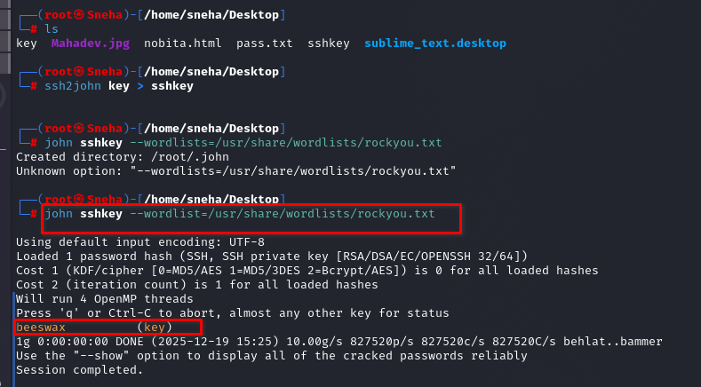

Insecure SSH Private Key Storage

Vulnerability | Insecure SSH Private Key Storage
Description | Following initial SSH access, the private SSH key belonging to another user was found to be readable due to improper file permissions. This allowed the attacker to extract and reuse the key to authenticate as a higher-privileged user.
Risk/Impact | Improper storage of private keys enables attackers to impersonate privileged users and bypass standard authentication controls.
CVSS Score | 8.1 High
Path: | 192.168.56.101
Remidiation / Solution | Mitigation  - Restrict permissions on .ssh directories and private keys  - Perform routine permission audits
Refrence Url: | https://attack.mitre.org/techniques/T1552/004/

Below screenshot shows that private key is not protected and by parsing key,attacker can access root user easily.

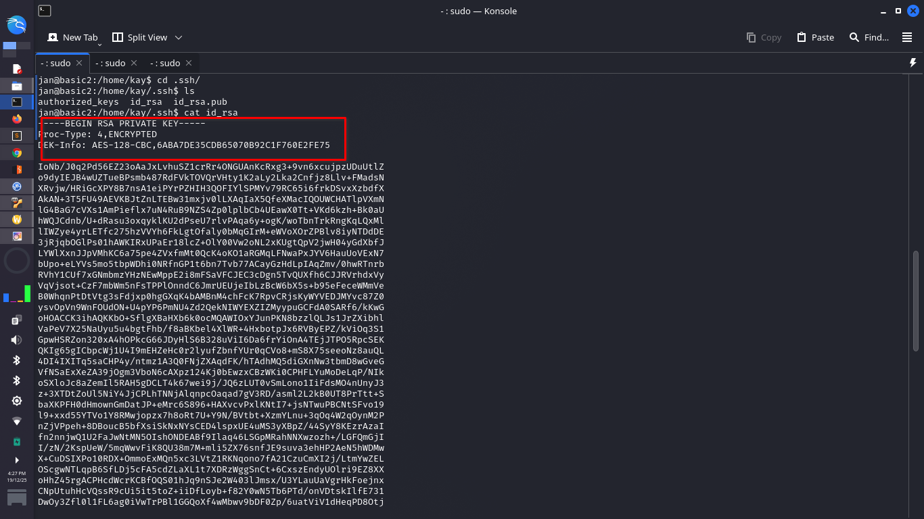

Unrestricted SMB Enumeration

Vulnerability | Unrestricted SMB Enumeration
Description | The SMB services running on ports 139 and 445 allowed unauthenticated enumeration of user and system information. This information contributed to reconnaissance and attack planning.
Risk/Impact | Exposed SMB information reduces attack complexity and supports further exploitation efforts.
CVSS Score | 5.0 Medium
Path: | 192.168.56.101
Remidiation / Solution | Mitigation  - Disable anonymous SMB access  - Restrict SMB services to trusted networks
Refrence Url: | https://attack.mitre.org/techniques/T1087/

Below screenshot shows the exposed user information which can help to enumerate more.

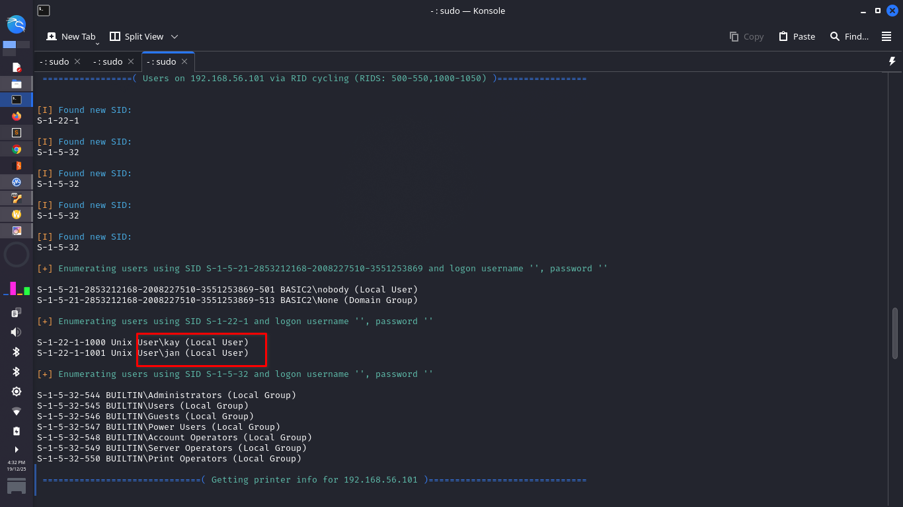

CONCLUSION:

The security assessment successfully demonstrated a complete system compromise resulting in root-level access. By chaining multiple misconfigurations across exposed network services, an attacker was able to progress from unauthenticated access to full administrative control of the system.

.Following initial access, improper SSH key management and weak passphrase protection enabled privilege escalation. The attacker successfully authenticated as the user kay, who possesses root-level privileges, and obtained full control of the system. As proof of successful compromise, the system flag was accessed and captured.

This assessment highlights how common configuration weaknesses—rather than advanced exploits—can be chained together to cause severe security impact. If exploited in a real organizational environment, these issues could lead to complete loss of system integrity, confidentiality, and availability. Immediate remediation and security hardening are strongly recommended.

Below screenshots demonstrating successful login as user kay and capture of the system flag.

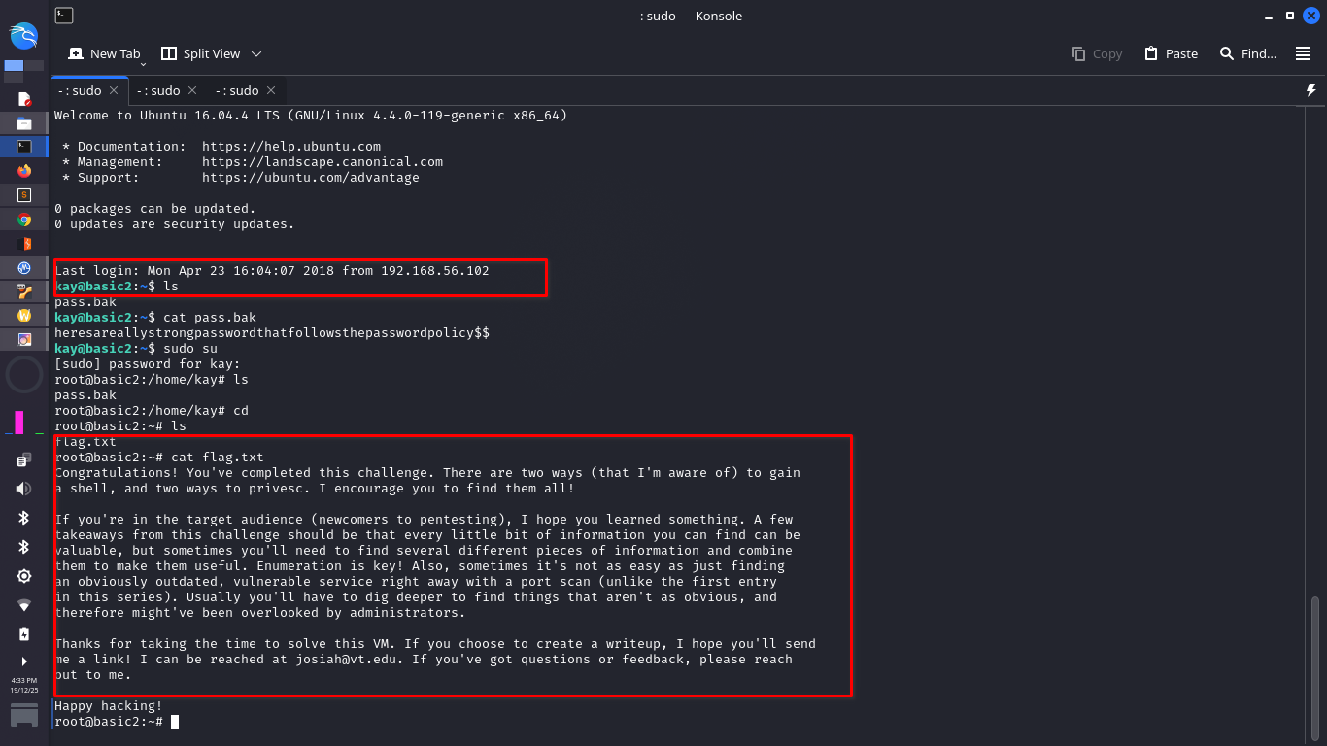

END OF REPORT

